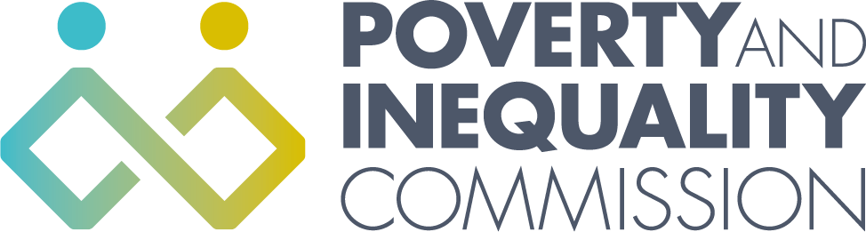

Thirteenth Meeting of the Poverty and Inequality Commission

Wednesday 3 April 2019
10:30am – 1:30pm
COSLA, Edinburgh

Commission Attendees
Douglas Hamilton, Chair
Kaliani Lyle, Deputy Chair
Katie Schmuecker
David Eiser

Apologies
Hugh Foy
Sally Witcher
Caroline Kennedy

In attendance
Bill Scott, Chair of the new Statutory Poverty and Inequality Commission

Secretariat Attendees
Katherine Hudson, Secretariat Manager
Katherine Myant, Analytical Manager
Michele Barr, Secretariat/Administrator
Mary Njoki, Postgraduate Intern

1. Welcome and apologies

Douglas opened the meeting and introduced the Commissioners to Mary Njoki, a Postgraduate intern who has joined the Secretariat for 3 months. Apologies were given for Hugh Foy, Sally Witcher and Caroline Kennedy.

2. Advocacy

Inclusive Growth Recommendations

Katherine Myant provided an update on the IPPR Scotland and Mark Diffley Consultancy and Research report on Inclusive Growth in Scotland. The Commission discussed recommendations and areas they would like to adopt for the Commission’s recommendations for the report. The Secretariat will meet with the research team to discuss the report and recommendations. A revised copy of the report will be circulated around the Commissioners.

Prior to publication the Commission will meet with the Cabinet Secretary for Finance, Fair Work and Economy to discuss the findings. The Commission will publish the report in May. The final report will be sent to Naomi Eisendstadt, previously Deputy Chair of the Commission.

3. Scrutiny

Budget Scrutiny update

Katherine Myant gave an update on the recent policy forum on how the Scottish Budget could be better used to tackle poverty. This was held on the 27th March and hosted by the Oxfam-UWS Partnership, alongside the Commission and The Poverty Alliance. The event brought together anti-poverty campaigners, those with lived experience, those involved in service delivery, and the participants of Oxfam’s Future Skills programme, to engage in participative workshops and explore how spending decisions could be made more inclusive and transparent.

A report which brings together all the aspects of the budget scrutiny will be published in May and the key findings from this event will be included in the report. Key priorities will be sent to the Cabinet Secretary for Finance, Fair Work and Economy.

Tackling Child Poverty Delivery Plan progress report

Katherine Hudson gave an overview of the draft paper for the Commission’s scrutiny of the Tackling Child Poverty Delivery Plan Progress Report, and asked the Commission for initial comments . The Scottish Government is providing updates on actions in the Delivery Plan to the Commission by 19 April. The Secretariat will circulate the full set of Scottish Government updates and a revised paper around the Commission at the end of April..

Poverty and Inequality statistics update

Katherine Myant gave an update on the recent poverty and inequality statistics that were published in March. The Commission provided a quote from Douglas Hamilton to the media in response to the statistics and this was picked up by BBC News, Daily Record and Third Force News. The following week, the Times published an opinion piece by Douglas Hamilton responding to the statistics.

For future media coverage the Commission discussed advance planning around Commission media releases.

4. Advice

School holidays

Douglas Hamilton provided a brief update on the Commission’s school holidays advice. The Commission has received an initial letter from the Cabinet Secretary for Communities and Local Government in response to the advice, and Douglas Hamilton has discussed the advice with Shirley Laing, Deputy Director of Social Justice and Regeneration at Scottish Government. The Scottish Government is planning to provide a more detailed response to the Commission’s recommendations shortly.

5. Other Business

Annual Public Meeting

The annual public meeting will take place on the 20 June at the Renfield Training Centre in Glasgow. The meeting will focus on key transport issues relating to poverty, housing wealth inequality in Scotland and will include an introduction to the new statutory Poverty and Inequality Commission.

Update on the statutory Poverty and Inequality Commission

Bill Scott provided an update on the statutory Commission’s recruitment of Commissioners. Applications closed on 1 April and sifting and interviews will take place at the end of April.

Update paper

Douglas Hamilton highlighted the update paper which covered updates on other aspects of the Commission’s work and meetings/events attended by Commissioners.

