Chair of the Poverty and Inequality Commission  Bill Scott  E: William.scott@povertyinequality.scot  Cabinet Secretary for Communities, Social Security and Equalities  By email  21 May 2018 | 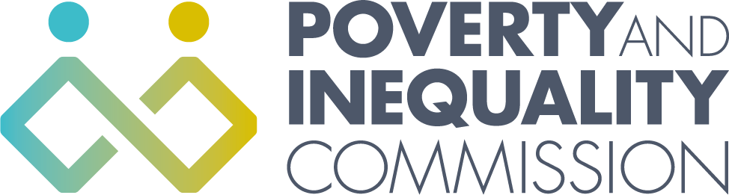
Nicola Sturgeon MSP
First Minister

By email

13 March 2020

Dear Ms Sturgeon,

Impact of coronavirus on families on low incomes

The current coronavirus outbreak has potentially serious implications for families on low incomes, the self-employed and those in insecure work. I have written today to the Secretary of State for Work and Pensions to ask for action on statutory sick pay for the self-employed and those on low pay and for work search conditions to be relaxed for those receiving benefits as we move into the ‘delay’ stage of response.

While there are no current plans to close schools I recognise that this may be necessary at some point in order to delay the spread of the virus. If this happens then children who are entitled to free school meals will not be able to access them. Free school meals are a vital part of enabling families on low incomes to manage and some children may go hungry if they are not available. I am writing to you as First Minister to ask what contingency plans are being made to ensure that children can access food if schools are closed.

I would be grateful for an update on the contingency plans that are in place and details of who has been involved in developing them.

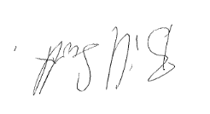

Bill Scott
Chair of Poverty and Inequality Commission

