Chair of the Poverty and Inequality Commission  Bill Scott  E: William.scott@povertyinequality.scot | 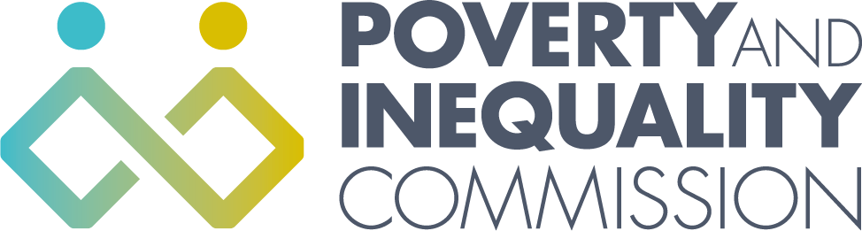
To: Thérèse Coffey MP
Secretary of State for Work and Pensions

by email

13 March 2020

Dear Dr Coffey,

Action needed to reduce the impact of coronavirus on people on low incomes

I am writing to you as Chair of the Poverty and Inequality Commission for Scotland about the action that needs to be taken to reduce the impact of the coronavirus outbreak on people on the lowest incomes. The virus itself and the measures that have to be taken to delay its spread are likely to increase the number of people experiencing poverty and hit those with the least resources hardest.

I welcome the action that has been taken by the UK Government so far to make Statutory Sick Pay available from day one to eligible individuals with coronavirus or who are self-isolating. The Commission is also pleased that the decision has been made to relax the Universal Credit minimum income floor for the self-employed and make contributory Employment and Support Allowance payable from day one of sickness absence.

More needs to be done, however, to protect the self-employed and low earners, who are least likely to have savings to support them through loss of earnings or a waiting period for Universal Credit. The Commission calls on you to extend Statutory Sick Pay to the two million workers who earn less than £118 per week and to the self-employed.

The Commission welcomes the decision to relax the requirement for anyone to physically attend a job centre. Now that we have moved into the delay phase, the Commission also asks you to lift work search requirements which may require people to use libraries and other communal settings in order to access a computer. This would reduce the risk of people spreading coronavirus by complying with work search requirements.

I look forward to hearing what action you will be taking on these issues.

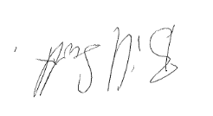

Bill Scott
Chair of Poverty and Inequality Commission

