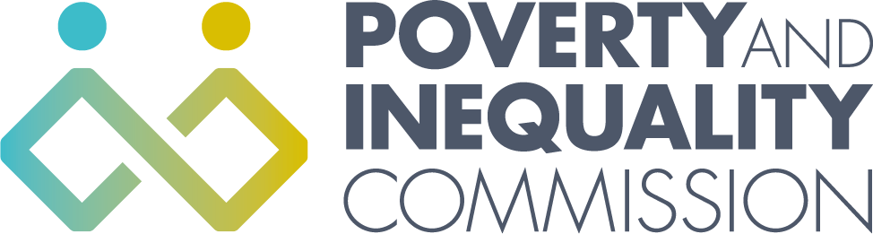
The Poverty and Inequality Commission Meeting - Thursday 18 March 2021
10:00am – 12:30 (Virtual meeting - Microsoft Teams)

Agenda

1. Welcome and apologies

2. Motability
- David Hunter, Motability and Access Committee for Scotland (MACS)

3. Child Poverty Modelling Report
- Emma Congreve, Fraser of Allander Institute, University of Strathclyde

4. Discussion: To explore the impact of the pandemic on housing debt and look at what further action may be needed to prevent this sweeping more people into poverty and homelessness.
Expert attendees:
Sally Thomas, CEO, Scottish Federation of Housing Associations
Jon Sparkes, Chief Executive, Crisis
John Blackwood, Chief Executive, Scottish Association of Landlords
Alison Watson, Director, Shelter Scotland
Nina Ballantyne, Strategic Lead for Social Justice, Citizens Advice Scotland

5. AOB

