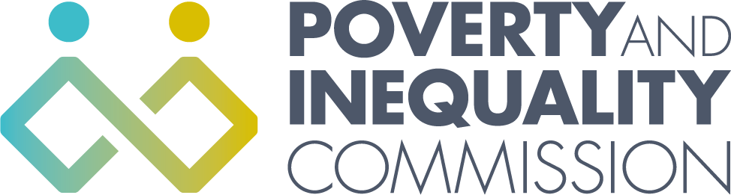

Meeting of the Poverty and Inequality Commission

Thursday 18 March 2021
10:00 – 12:30
Virtual Meeting by Microsoft Teams

Attendees
Bill Scott, Chair
Professor Morag Treanor
Lindsay Graham
Linda Bamford
Alex Cobham
Katie Schmuecker
Douglas White
Shona Stephen

Secretariat attendees
Katherine Hudson, Secretariat Manager
Rory Morrison, Analytical Manager
Michele Barr, Secretariat/Administrator

Apologies
Yvonne Blake

External attendees

Item 2
David Hunter, Mobility and Access Committee for Scotland (MACS)

Item 3
Emma Congreve, Fraser of Allander Institute, University of Strathclyde
Mark Mitchell, Fraser of Allander Institute, University of Strathclyde
Professor Peter McGregor, Fraser of Allander Institute, University of Strathclyde
Kevin Connolly, Fraser of Allander Institute, University of Strathclyde
Professor Ashwin Kumar, Manchester Metropolitan University
Jordan Harrison, Manchester Metropolitan University

Item 4
Sally Thomas, CEO, Scottish Federation of Housing Associations
Jon Sparkes, Chief Executive, Crisis
John Blackwood, Chief Executive, Scottish Association of Landlords
Alison Watson, Director, Shelter Scotland
Nina Ballantyne, Strategic Lead for Social Justice, Citizens Advice Scotland

1. Welcome and apologies

Bill Scott welcomed everyone to the meeting, apologies were given for Yvonne Blake.

10:00-10:20

2. Motability

David Hunter, from the Mobility and Access Committee for Scotland (MACS), provided the Commissioners with an overview of Personal Independence Payment (PIP) Motability Scheme and improving governance and value for money in the Motability scheme in Scotland. This was followed by a discussion with the Commission. The Commission agreed that it would call for Scottish Government to review the Motability scheme when adult disability payments are reviewed. The review of Adult Disability Payment is scheduled to take place in “summer 2023”.

10:20-11:00

3. Child Poverty Modelling Report

Emma Congreve, from the Fraser of Allander Institute at the University of Strathclyde, gave a presentation to the Commission on the Child Poverty Modelling report. The Commission provided a grant to Fraser of Allander Institute support it to undertake modelling work to explore how the child poverty targets can be met by changing key drivers of child poverty to the extent required to meet the interim and final targets. Commissioners discussed the research findings and agreed to a follow-up meeting to discuss the report in more detail.

11:00-12:30

4. Discussion: to explore the impact of the pandemic on housing debt and look at what further action may be needed to prevent this sweeping more people into poverty and homelessness.

Shona Stephen, Commissioner, chaired the housing debt discussion. Shona welcomed the expert attendees to the meeting. The Commission heard short presentations from:

Sally Thomas, CEO, Scottish Federation of Housing Associations
Jon Sparkes, Chief Executive, Crisis
John Blackwood, Chief Executive, Scottish Association of Landlords
Alison Watson, Director, Shelter Scotland
Nina Ballantyne, Strategic Lead for Social Justice, Citizens Advice Scotland

Following the presentations the Commissioners held a discussion with the experts about the key issues relating to the impact of the pandemic on housing debt. The Commission agreed that it would consider what more it might do on housing debt at a future Commission meeting.

5. AOB

- The next Commission meeting will be on the 29 April.

