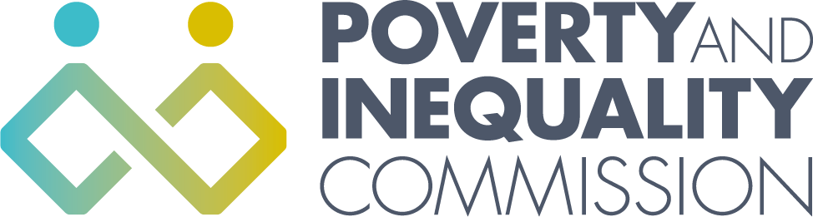
The Poverty and Inequality Commission Meeting - Thursday 25 November 2021
10:00 – 12:00 (Virtual meeting - Microsoft Teams)

Agenda

1. Welcome and apologies
2. Child Poverty Delivery Plan advice
3. AOB

