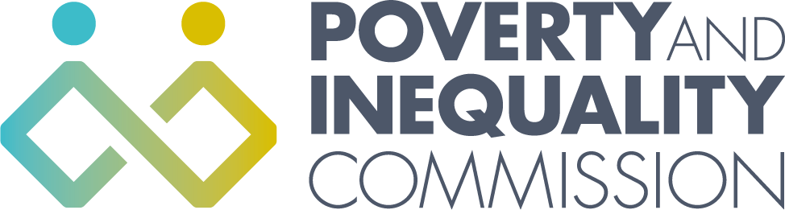
The Poverty and Inequality Commission Meeting - Thursday 28 October 2021
10:00 – 12:00 (Virtual meeting - Microsoft Teams)

Agenda

1. Welcome and apologies
2. Learning and Work Institute – Good Jobs in Scotland Research (10:00-11:00)
Expert attendees:
Naomi Clayton, Interim Director for Policy and Research, Learning & Work Institute,
Daniela Cabral, Research Manager, Learning & Work Institute
Beth Cocker, Secretariat for the Fair Work Convention, Scottish Government
3. Child Poverty advice – reflections on work so far (11:00-12:00)
- AOB

