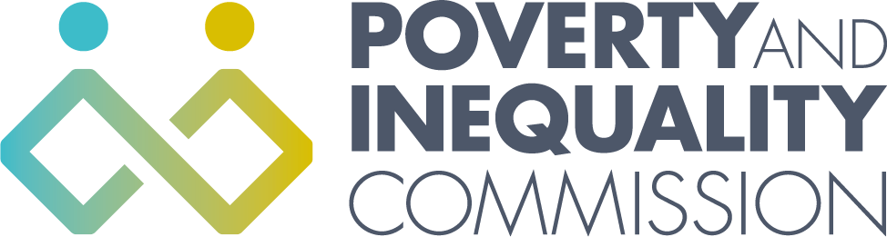

Joint Meeting of the Poverty and Inequality Commission
Panel Members and Commissioners

Thursday 11 November 2021
10:00 – 12:00
Virtual Meeting by Zoom

Attendees

Poverty and Inequality Commission members
Experts by experience panel members
Poverty and Inequality Commission secretariat

1. Welcome and introductions

The Commission’s Senior Participation Officer welcomed everyone to the meeting and asked everyone to introduce themselves. She set out that the meeting would build on the separate child poverty discussions that both the Commission and Panel had previously had. The purpose of this joint meeting was for the Commission and Panel to start to develop a shared understanding of the issues and potential solutions, to inform the Commission’s advice to the Scottish Government on the next Child Poverty Delivery Plan.

The Commission Chair then spoke about why the Commission wanted to establish and work with a Panel of Experts by Experience, and highlighted the importance of the Panel in shaping and supporting the work of the Commission over the next year.

2. Commission/Panel Discussions

The Commissioners and Panel members participated in a number of break out discussions to explore and build on some of the ideas that had come out of previous Panel discussions about child poverty.

3. Commission/Panel Q&A

There was an opportunity for the Commission and Panel to ask each other questions about the Child Poverty Delivery Plan advice and other relevant issues.

