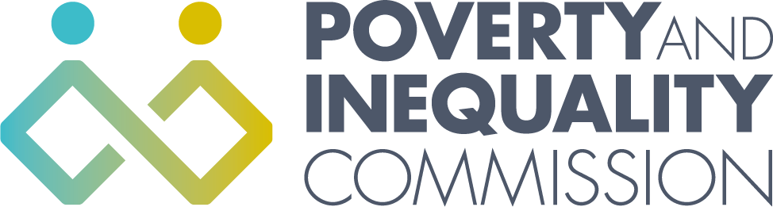

Meeting of the Poverty and Inequality Commission

Thursday 25 November 2021
10:00 – 12:00
Virtual Meeting by Microsoft Teams

Attendees
Bill Scott, Chair
Lindsay Graham
Linda Bamford
Shona Stephen
Alex Cobham
Katie Schmuecker

Secretariat attendees
Katherine Hudson, Secretariat Manager
Rory Morrison, Analytical Manager
Orlaith McAree, Senior Participation Officer
Michele Barr, Secretariat/Administrator

Apologies
Yvonne Blake
Douglas White
Professor Morag Treanor

1. Welcome and apologies

Bill Scott welcomed everyone to the meeting apologies were given for Yvonne Blake, Douglas White and Morag Treanor.

2. Child Poverty Delivery Plan advice

Katherine Hudson presented a draft of the Commission’s Child Poverty Delivery Plan advice. This draft had been developed following the joint meeting between the Commission and the experts by experience Panel to consider key issues and potential recommendations. The Commissioners discussed the initial draft of the advice and discussed in more detail possible recommendations they would like to make to Scottish Government. Commissioners were asked to email any further comments to the Secretariat. The Commission’s Child Poverty Delivery Plan advice will be provided to Scottish Government in December 2021 and published in January 2022.

4. AOB
- The next Commission meeting will be on the 20 January 2022.

