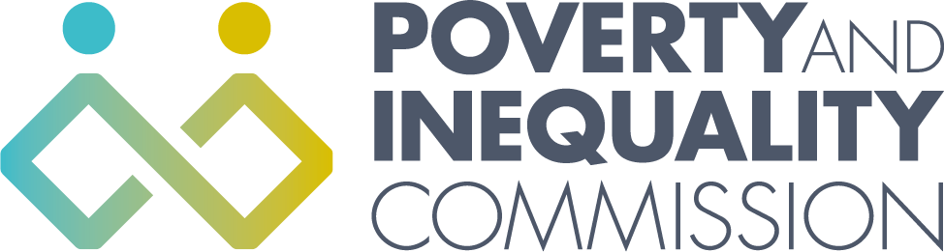

Meeting of the Poverty and Inequality Commission

Thursday 28 October 2021
10:00 – 12:00
Virtual Meeting by Microsoft Teams

Attendees
Bill Scott, Chair
Professor Morag Treanor
Lindsay Graham
Linda Bamford
Yvonne Blake
Shona Stephen
Douglas White
Alex Cobham

Secretariat attendees
Katherine Hudson, Secretariat Manager
Rory Morrison, Analytical Manager
Orlaith McAree, Senior Participation Officer
Michele Barr, Secretariat/Administrator

Apologies
Katie Schmuecker

External attendees
Naomi Clayton, Interim Director for Policy and Research, Learning & Work Institute,
Daniela Cabral, Research Manager, Learning & Work Institute
Beth Cocker, Secretariat for the Fair Work Convention, Scottish Government

1. Welcome and apologies

Bill Scott welcomed everyone to the meeting apologies were given for Katie Schmuecker.

10:00-11:00

2. Learning and Work Institute – Good Jobs in Scotland Research

Naomi Clayton and Daniela Cabral, Learning and Work Institute, gave a presentation to the Commission on the Good Jobs in Scotland research. The report will inform the Commission’s statutory child poverty advice to the Scottish Government on its next tackling child poverty delivery plan. Commissioners gave feedback on the research findings and will provide more detailed comments to the secretariat on the research in order for Learning and Work Institute to finalise the report.

External attendees left the meeting.

11:00-12:00

3. Commission business as usual

Child Poverty advice – reflections on work so far

Katherine Hudson presented to the Commissioners the mapping of the Child Poverty Delivery Plan advice, Commissioners discussed the mapping and provided amendments. Commissioners will provide feedback on any recommendations they would like to make and any particular ideas or issues that they would want to discuss with the experts by experience panel on 11 November. Recommendations to be sent to the secretariat.

4. AOB
- Commissioners discussed a request received from the University of New South Wales inviting Commissioners to participate in a project about the successes that the Scottish Poverty and Inequality Commission has had in countering poverty or economic inequality. Morag Treanor has already been interviewed, Bill Scott, Douglas White and Alex Cobham would be happy to be interviewed as well.
- The Commission and Panel of Experts by Experience will meet to discuss the child poverty advice on the 11 November 2021.
- The next Commission meeting will be on the 25 November 2021.

