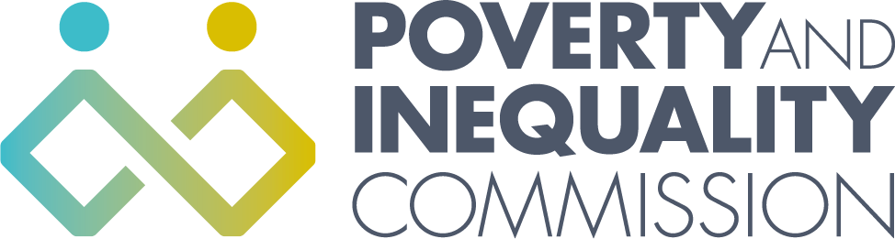

Meeting of the Poverty and Inequality Commission

Thursday 30 September 2021
10:00 – 12:30
Virtual Meeting by Microsoft Teams

Commission attendees
Bill Scott, Chair
Professor Morag Treanor
Yvonne Blake
Douglas White
Linda Bamford
Shona Stephen
Alex Cobham
Katie Schmuecker

External attendees
Alison Watson Director, Shelter Scotland
John Blackwood Chief Executive, Scottish Association of Landlords
Deborah Hay Scotland Policy and Partnership Manager, JRF
Laura Caven Policy Manager – Communities, COSLA
Eileen McMullan Policy Lead, SFHA
Derek McGowan Chief Officer – Early Intervention and Community Empowerment, Aberdeen City Council
Claire McCrum Child Poverty Team Leader, Scottish Government
Colin MacBean Deputy Director – More Homes, Scottish Government

Secretariat attendees
Katherine Hudson, Secretariat Manager
Rory Morrison, Analytical Manager
Orlaith McAree, Senior Participation Officer

Apologies
Lindsay Graham Commissioner
Catriona MacKean Deputy Director – Better Homes, Scottish Government
Spencer Thompson Economic Adviser, Scottish Government

- Welcome and apologies

Bill Scott welcomed everyone to the meeting and asked everyone to introduce themselves. Apologies were given for Lindsay Graham, Catriona MacKean and Spencer Thompson.

- Discussion: Advice to Scottish Government on the next Child Poverty Delivery Plan. What contribution can housing make towards meeting the child poverty targets? (10:00-11:15)

The Commission and external attendees discussed what contribution action on housing should make to reaching the child poverty targets. This discussion will inform the Commission’s advice to the Scottish Government on the next Child Poverty Delivery Plan.

External attendees left the meeting.

- Annual Scrutiny Report

Rory Morrison gave an overview of progress in developing the Commission’s annual scrutiny report. The Commission discussed some additional issues that could be explored in the report and ways of presenting the report that would illustrate the connections between different policies and draw out more strongly the voices of those with lived experience. The Commission agreed that it would be appropriate to develop two or three over-arching observations as conclusions to the report, rather than providing detailed recommendations. It was noted that the additional work would require more time and that publication should be planned for later in November.

- Request for feedback on COVID-19 Public Inquiry aims and principles

The Commission considered a request for feedback on the aims and principles of the COVID-19 Inquiry. The Commission agreed that it would like to see the aims of the inquiry include explicit reference to the impact of the pandemic on poverty and inequality. It was agreed that the secretariat should provide feedback to the Inquiry set up team on a number of areas, including looking at: the impact on those with protected characteristics and those experiencing existing inequality; learning lessons from the pandemic response for other major societal issues such as poverty; and ensuring the accessibility of the Inquiry.

- Budget/Risk Register/Work Programme

The Commission considered the Commission budget, risk register and work programme.

- AOB
- The next Commission meeting will be on 28 October 2021.

